**Name: Nafinur Leo**

**Id: 20-42195-1**

**Course Name: Data Communication**

**Section: D**

**Lab Exam: 01**

**Semester: 2021-2022 Fall**

**Submission Date: 29-11-2021**

ID = AB-CDEFG-H

Here, my id is: 20-42195-1

A = 2, B = 0, C = 4, D = 2, E = 1, F = 9, G = 5, H = 1

a1 = F+4 = 9+4 = 13

f1 = G+3 = 5+3 = 8

a2 = F+2 = 9+2 = 11

f2 = G+5 = 5+5 = 10

Start range = (G+1)*70 = (5+1)*70 = 420 Hz

End range = (G+1)*110 = (5+1)*110 = 660 Hz

Code:

clc

clear all

close all

fs = 4001;

t = 0:1/fs:1-1/fs;

a1 = 13;

f1 = 8;

s1 = a1*cos(2*pi*f1*t);

a2 = 11;

f2 = 10;

s2 = a2*cos(2*pi*f2*t);

Cm1 = 1;

fc1 = 460;

c1 = Cm1*cos(2*pi*fc1*t);

Cm2 = 1;

fc2 = 500;

c2 = Cm2*cos(2*pi*fc2*t);

x = (s1).*c1+(s2).*c2;

figure

subplot(3,1,1)

plot(t,s1)

xlabel('time')

ylabel('amplitude')

title('Message Signal 1 in time domain')

ylim([-a1 a1])

subplot(3,1,2)

plot(t,s2)

xlabel('time')

ylabel('amplitude')

title('Message Signal 2 in time domain')

ylim([-a2 a2])

M1 = abs(fftshift(fft(s1)))/(fs/2);

M2 = abs(fftshift(fft(s2)))/(fs/2);

X = abs(fftshift(fft(x)))/(fs/2);

f = fs/2*linspace(-1,1,fs);

figure

subplot(3,1,1)

stem(f,M1)

xlabel('frequency')

ylabel('amplitude')

title('Message Signal 1 in frequency domain')

axis([-10 10 0 10])

subplot(3,1,2)

stem(f,M2)

xlabel('frequency')

ylabel('amplitude')

title('Message Signal 2 in frequency Domain')

axis([-12 12 0 20])

figure

subplot(2,1,1)

plot(t,x)

xlabel('time')

ylabel('amplitude')

title('Composite/multiplexed signal in time domain')

subplot(2,1,2)

stem(f,X)

xlabel('frequency')

ylabel('amplitude')

title('Composite/multiplexed signal in frequency domain')

axis([-660 660 0 10])

[num1, den1] = butter(5, [(fc1-f1-6)/(fs/2),(fc1+f1+6)/(fs/2)]);

bpf1 = filter(num1,den1,x);

[num2, den2] = butter(5, [(fc2-f2-6)/(fs/2),(fc2+f2+6)/(fs/2)]);

bpf2 = filter(num2,den2,x);

z1 = 2*bpf1.*c1;

z2 = 2*bpf2.*c2;

[num4, den4] = butter(5, (f1+3)/(fs/2));

rec1 = filter(num4,den4,z1);

[num5, den5] = butter(5, (f2+3)/(fs/2));

rec2 = filter(num5,den5,z2);

figure

subplot(3,1,1)

plot(t,rec1)

xlabel('time')

ylabel('amplitude')

title('Received signal 1 in time domain')

ylim([-a1 a1])

subplot(3,1,2)

plot(t,rec2)

xlabel('time')

ylabel('amplitude')

title('Received signal 2 in time domain')

ylim([-a2 a2])

R1 = abs(fftshift(fft(rec1)))/(fs/2);

R2 = abs(fftshift(fft(rec2)))/(fs/2);

figure

subplot(3,1,1)

stem(f,R1)

xlabel('frequnecy')

ylabel('amplitude')

title('Received signal 1 in frequency domain')

xlim([-10 10])

subplot(3,1,2)

stem(f,R2)

xlabel('frequnecy')

ylabel('amplitude')

title('Received signal 2 in frequency domain')

xlim([-10 10])

(i)

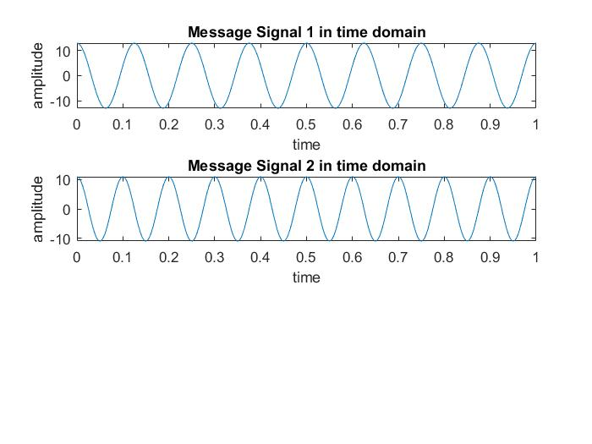

(ii)

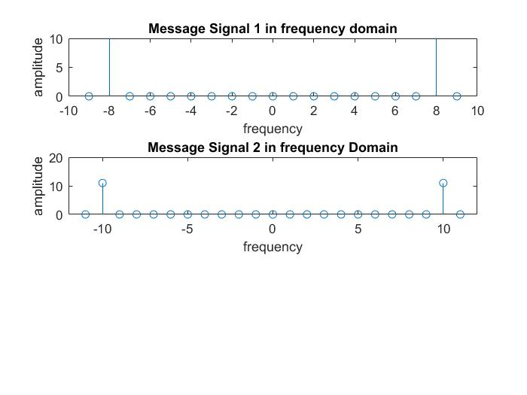

(iii)

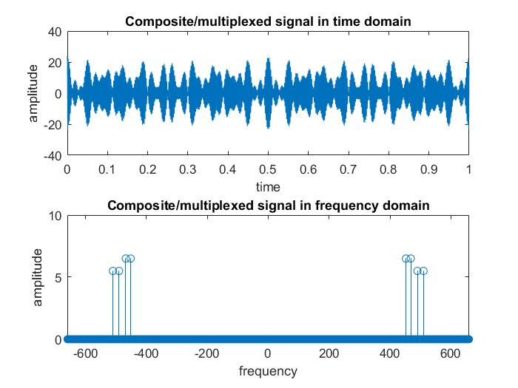

(iv)

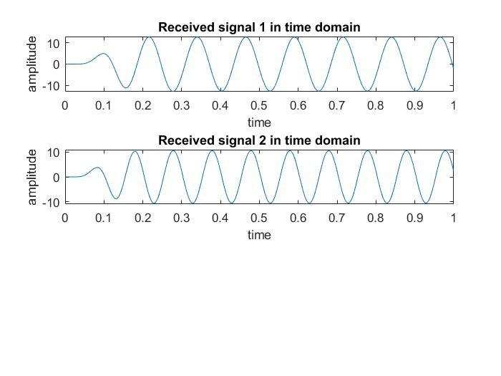

(v)

